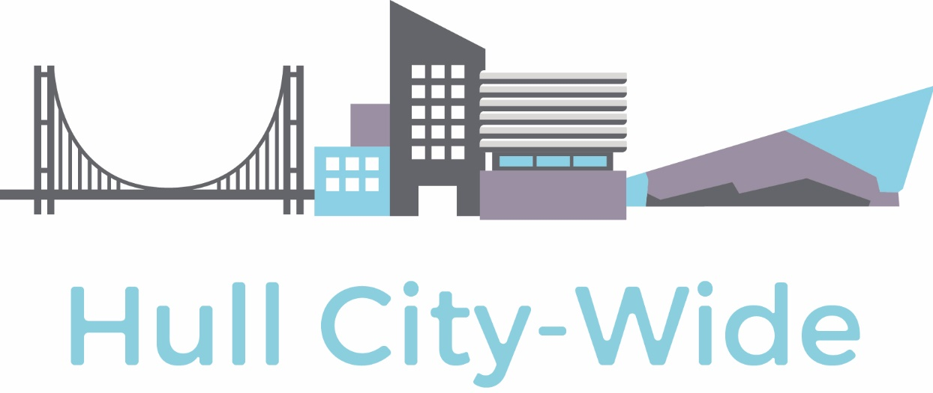

- Citywide Partners support Roots to Roofs School programme in Hull

Overview

The Roots to Roof final is a STEM and Enterprise activity promoting careers in Construction. We are inspiring primary school children to understand more about the many different career opportunities in our industry and stress it is for girls and boys! We go into the classroom where they work in small teams and design a 2d model of a house including any Eco-friendly options, this is a hands-on activity and we take in activity packs for them to use. They have a budget so have to work out costs and decide on materials to use, they then present their ideas to the class. We are promoting employability skills of teamwork, communication, budgeting and presentation skills.

We then ask them to bring their ideas to life by building a 3d model using recycled materials. Industry Ambassadors work with the pupils at the launch and also go back to judge a winning model from each school that has participated, and this entry then goes through to the final. We have had excellent support from local employers and the Citywide Partnership with their sponsorship of the top 3 prizes and the best team player awards.

This project has grown from 5 schools participating in 2018 to 11 schools in 2019 and we are looking forward to this growing on an annual basis so we can excite and inspire the next generation to make construction a career of choice.

Key Features
Delivered in partnership with 11 local and national construction companies, CITB, Hull City Council and Hull Training providing industry expertise throughout the programme. Pupils also had a tour around the construction centre at Hull Training, looking at a range of different trade roles

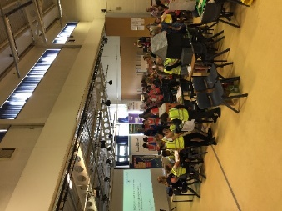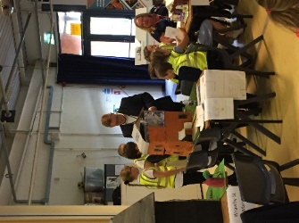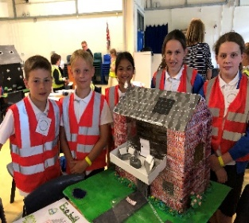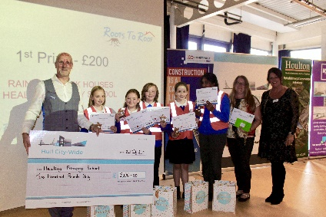

Outcomes
- 11 primary schools across the Humber region took part in the programme, with over 400 pupils engaged in developing a housing company and learning about all aspects of the industry
- Prizes were awarded to the top 3 with the winning school receiving a cheque for £200, £150 for second runner up and £100 for 3rd. There was also recognition for one member from each school that had been the best team player. Every pupil received a goodie bag with items provided by all of the contractors involved in the programme

“The programme is so important in bringing forward the next generation of construction employees. The ideas and innovation that many of the teams demonstrated in creating their companies and models shows that there is some real future talent.”

Social & Economic Impact Manager

Mark Burley Citywide Partnership

